The Islamia University of Bahawalpur
Department of Information Technology

Software Requirement Specifications
(SRS DOCUMENT)
for
UniHirex
(Recruitment Portal for University Students)

BY
Sehar Tahir
S23BINFT1M01030

SUPERVISOR
Sir Ali Nawaz Shah

Bachelor of Science in Information Technology
Faculty of Computing
The Islamia University of Bahawalpur

Revision History
Name | Date | Reason of Change | Version
UniHirex -V1 | 26/4/2026 | Verion1 of UniHirex – Recruitment Portal for University Students | V1

Document Approval
The following SRS has been accepted and approved by the following
Signature | Printed Name | Title | Date

Summary
This document presents the Software Requirements Specification (SRS) for UniHirex -Recruitment Portal for University Students, developed specifically for students of The Islamia University of Bahawalpur. The project addresses the common issue where students, especially freshers, possess relevant skills but face difficulties in finding suitable job and internship opportunities, while recruiters struggle to connect with a targeted pool of candidates.
The system is designed to provide a centralized platform where students can create profiles, upload resumes, search for jobs, and apply for opportunities. Recruiters can post job listings, review applications, and manage the hiring process efficiently. The system also includes an administrative module to monitor and manage users and system activities.
The document outlines the functional and non-functional requirements, system features, user interactions, and overall process flow through UML diagrams. The proposed system is developed using modern web technologies, ensuring a scalable, user-friendly, and efficient solution to streamline the recruitment process within the university environment.

Table of Contents
1 Introduction 6
1.1 Purpose 7
1.2 Scope 7
1.3 Definitions, Acronyms, Abbreviations 8
1.4 Product Perspective 8
1.5 User Characteristics 9
1.6 Proposed Technologies 9
1.7 Similar Apps and Systems / Literature 10
2 Overall Description 10
2.1 System Overview 11
2.2 System Features 11
3 Functional Requirements 12
3.1 User Registration 12
3.2 User Login 12
3.3 Student Profile Management 13
3.4 Resume Upload 13
3.5 Job Search and Filtering 13
3.6 Job Application 13
3.7 Recruiter Job Posting 14
3.8 Application Management 14
3.9 Admin Management 14
4 Nonfunctional Requirements 14
4.1 Performance Requirements 15
4.2 Security Requirements 15
4.3 Usability Requirements 15
4.4 Reliability Requirements 15
5 Use Cases and Flow of Processes 16
5.1 Use Cases 16
5.1.1 Use Case Diagram 17
5.1.2 Activity Diagram 17
5.1.3 Class Diagram 19
5.1.4 UML Diagram 20
5.1.5 Sequence Diagram 21
5.1.6 System Architecture Diagram 22
5.2 Use Case Descriptions 22
5.2.1 Use Case 1 23
5.2.2 Use Case 2 25
5.2.3 Use Case 3 26
5.2.4 Use Case 4 28
5.2.5 Use Case 5 29
5.2.6 Use Case 6 30
5.2.7 Use Case 7 32
5.2.8 Use Case 8 33
5.2.9 Use Case 9 35
6 References 36

Introduction
The Islamia University of Bahawalpur (IUB) is a well-established public sector university offering a variety of undergraduate and postgraduate programs. Every year, a large number of students graduate with different academic and technical skills. However, many of these students face difficulties in finding relevant internships and entry-level job opportunities due to the lack of a centralized recruitment system within the university.
Currently, students depend on external platforms and informal sources such as social media to search for jobs, which are often not tailored for fresh graduates. Similarly, recruiters find it difficult to reach a targeted pool of students from the university. This creates a gap between skilled students and potential employers.
To address this issue, the proposed system “UniHirex – Recruitment Portal for University Students” will be developed as a web-based platform specifically for IUB students. The system will allow students to create profiles, upload resumes, and apply for jobs and internships, while recruiters can post opportunities and manage applications efficiently.

Purpose
The purpose of this project is to design and develop a web-based recruitment portal, UniHirex, for students of The Islamia University of Bahawalpur. The system aims to provide a centralized platform that connects students with recruiters, enabling efficient access to job and internship opportunities.
The main objective of UniHirex is to simplify the recruitment process by allowing students to create professional profiles, upload resumes, and apply for relevant positions, while enabling recruiters to post job opportunities and manage applications effectively. The system is intended to reduce the gap between students and employers and provide a structured and organized environment for university-level hiring.
Additionally, this document serves as a Software Requirements Specification (SRS) to clearly define the functional and non-functional requirements of the system, ensuring a shared understanding among stakeholders and guiding the development process

Scope
The scope of the project “UniHirex - Recruitment Portal for University Students” is to develop a web-based system that facilitates interaction between students and recruiters within The Islamia University of Bahawalpur. The system will provide a centralized platform where students can register, create and manage their profiles, upload resumes, search for job and internship opportunities, and apply online. Recruiters will be able to create accounts, post job openings, and manage applications received from students. An administrative module will also be included to monitor system activities and manage users.
The system will focus on supporting entry-level recruitment and internship opportunities specifically for university students and fresh graduates. It will ensure a user-friendly interface and secure access for all types of users.
However, the project will not include features such as integration with external job portals, mobile application development, or advanced analytics and recommendation systems. Additionally, the system will not support large-scale enterprise recruitment processes beyond the university level.

Definitions, Acronyms, Abbreviations
This section defines the key terms, acronyms, and abbreviations used throughout this document to ensure clarity and understanding.
- IUB (The Islamia University of Bahawalpur): The institution for which the system is being developed.
- UniHirex: The proposed web-based recruitment portal for university students.
- User: Any individual interacting with the system, including students, recruiters, and administrators.
- Student: A registered user who can create a profile, upload a resume, and apply for jobs or internships.
- Recruiter: A user who represents a company or organization and can post job opportunities and review applications.
- Admin: The system administrator responsible for managing users, monitoring activities, and maintaining system integrity.
- Job Posting: An advertisement created by a recruiter describing a job or internship opportunity.
- Application: A submission made by a student in response to a job posting.
- MERN Stack: A web development stack consisting of MongoDB, Express.js, React.js, and Node.js.
- JWT (JSON Web Token): A method used for secure authentication and authorization of users.

Product Perspective
The proposed system, UniHirex, is a standalone web-based application designed to serve as a centralized recruitment platform for students of The Islamia University of Bahawalpur. It is not intended to replace any existing system within the university but rather to provide an additional digital solution that improves the recruitment process for students and recruiters.
UniHirex will function as an independent system that integrates multiple modules, including student management, recruiter management, job posting, and application handling. These modules will work together to support the complete recruitment workflow, from job posting by recruiters to application submission by students and final candidate selection.
The system will operate through a web interface accessible via browsers and will use a client-server architecture. The frontend will handle user interaction, while the backend will manage business logic and database operations. Overall, the developed module will fit into the system as a comprehensive recruitment solution that connects students and employers within a single platform.

User Characteristics
The UniHirex system will be used by three primary types of users: students, recruiters, and administrators. Each user group has different roles, responsibilities, and levels of interaction with the system.
- Students
Students are the main users of the system. They are expected to have basic knowledge of web applications and internet usage. Students will use the platform to create profiles, upload resumes, search for job and internship opportunities, and apply for positions. They are generally familiar with online platforms but may vary in technical expertise.
- Recruiters
Recruiters represent companies or organizations looking to hire students or fresh graduates. They are expected to have basic to moderate computer skills. Recruiters will interact with the system to create company profiles, post job openings, review applications, and shortlist candidates. Their focus is on efficiently managing recruitment activities.
- Administrators (Admin)
Administrators are responsible for managing and maintaining the system. They are expected to have a higher level of technical knowledge compared to other users. Admins will monitor user activities, manage accounts, oversee job postings, and ensure the smooth functioning and security of the platform.

Proposed Technologies
The development of the UniHirex system will be based on modern web technologies to ensure efficiency, scalability, and ease of use. The following technologies are proposed for implementing the system:
- Frontend
React.js will be used to develop the user interface, providing a responsive and interactive experience for users.
- Backend
Node.js with Express.js will be used to handle server-side logic, API development, and communication between the frontend and database.
- Database
MongoDB will be used as a NoSQL database to store user data, job postings, and application records.
- Authentication
JSON Web Tokens (JWT) will be used to implement secure user authentication and authorization.
- Development Tools
Visual Studio Code (VS Code) will be used as the development environment, Git for version control, and Postman for API testing.

Similar Apps and Systems / Literature
Several online recruitment platforms exist that connect job seekers with employers, such as LinkedIn, Indeed, and Glassdoor. These platforms provide features like job searching, profile creation, and application management. However, they are designed for a broad audience and often focus on experienced professionals rather than university students and fresh graduates.
In the context of university-level recruitment, some institutions use internal job portals or career service platforms to assist students. These systems are usually limited in functionality or not widely adopted, which reduces their effectiveness.
The proposed system, UniHirex, differs from these platforms by focusing specifically on students of The Islamia University of Bahawalpur. It aims to provide a simple and targeted solution for entry-level jobs and internships. By offering a centralized platform tailored to university students and recruiters, UniHirex addresses the gap left by general-purpose job portals and provides a more relevant and accessible recruitment system.

Overall Description
This section provides a general overview of the UniHirex system, describing its main functionalities, operating environment, and the overall structure of the system. It outlines how the system will operate from a high-level perspective without going into detailed requirements.
UniHirex is designed as a web-based recruitment platform that connects students of The Islamia University of Bahawalpur with recruiters offering job and internship opportunities. The system will support multiple user roles, including students, recruiters, and administrators, each with specific functionalities and access levels.
The platform will enable students to manage their profiles, search and apply for jobs, while recruiters will be able to post job openings and manage applications. The admin will oversee the system to ensure smooth operation and data integrity. The system is intended to be user-friendly, efficient, and accessible through standard web browsers.

System Overview
UniHirex is a web-based recruitment system designed to facilitate the interaction between students and recruiters within The Islamia University of Bahawalpur. The system provides a centralized platform where students can explore job and internship opportunities, while recruiters can identify and select suitable candidates.
The system follows a client-server architecture, where users access the platform through a web browser. The frontend interface allows users to interact with the system, while the backend handles data processing, business logic, and communication with the database.
UniHirex consists of three main user roles: students, recruiters, and administrators. Students can create and manage their profiles, upload resumes, search for available opportunities, and apply for jobs. Recruiters can create company profiles, post job openings, and review applications submitted by students. Administrators are responsible for managing users, monitoring system activities, and ensuring the overall functionality of the platform.
The system is designed to provide a structured and efficient recruitment process, improving accessibility to job opportunities for students and simplifying candidate selection for recruiters.

System Features
The UniHirex system provides a set of core features that support the recruitment process for students and recruiters. These features are designed to ensure smooth interaction between users and efficient management of job opportunities and applications.
- User Registration and Authentication
The system allows students and recruiters to create accounts and securely log in to access their respective functionalities.
- Student Profile Management
Students can create and update their profiles by adding personal information, educational background, skills, and other relevant details.
- Resume Upload
Students can upload their resumes to support their job applications and provide additional information to recruiters.
- Job and Internship Search
Students can browse and search for available job and internship opportunities using basic filtering options.
- Job Application
Students can apply for jobs directly through the system and track their application status.
- Recruiter Job Posting
Recruiters can create and manage job postings by providing details such as job description, requirements, and deadlines.
- Application Management
Recruiters can view applications submitted by students, evaluate candidates, and shortlist suitable applicants.
- Admin Management
The administrator can manage user accounts, monitor system activities, and ensure that the platform operates smoothly and securely.

Functional Requirements
This section describes the functional requirements of the UniHirex system. Each requirement defines a specific functionality of the system, including its purpose, users, inputs, and expected outputs.

User Registration
- Name: FR001
- Purpose: The registration process allows new users (students and recruiters) to create an account and become members of the system.
- User(s): Student, Recruiter
- Input:
o Full Name: User’s official name
o Email: Valid email address (must be unique)
o Password: Must be at least 8 characters long
o Role Selection: Student or Recruiter
o Phone Number: Valid contact number
- Output: User account is successfully created, and the user can log in to the system.

User Login
- Name: FR002
- Purpose: Allows registered users to securely access the system using their credentials.
- User(s): Student, Recruiter, Admin
- Input:
o Email: Registered email address
o Password: User’s password
- Output: User is authenticated and redirected to their respective dashboard.

Student Profile Management
- Name: FR003
- Purpose: Enables students to create and manage their professional profiles.
- User(s): Student
- Input:
o Personal Information: Name, contact details
o Education Details: Degree, university, CGPA
o Skills: Technical and soft skills
o Projects/Experience: Relevant work or academic projects
- Output: Student profile is created or updated and visible to recruiters.

Resume Upload
- Name: FR004
- Purpose: Allows students to upload their resumes for job applications.
- User(s): Student
- Input:
o Resume File: PDF or document format
- Output: Resume is successfully uploaded and linked to the student profile.

Job Search and Filtering
- Name: FR005
- Purpose: Enables students to search and filter job and internship opportunities.
- User(s): Student
- Input:
o Keywords: Job title or skill
o Filters: Location, job type, category
- Output: A list of relevant job opportunities is displayed.

Job Application
- Name: FR006
- Purpose: Allows students to apply for jobs or internships.
- User(s): Student
- Input:
o Selected Job: Job chosen by the student
o Resume: Uploaded resume
- Output: Application is submitted successfully and stored in the system.

Recruiter Job Posting
- Name: FR007
- Purpose: Allows recruiters to post job or internship opportunities.
- User(s): Recruiter
- Input:
o Job Title: Name of the position
o Description: Job details and responsibilities
o Requirements: Required skills and qualifications
o Deadline: Application closing date
- Output: Job posting is created and visible to students.

Application Management
- Name: FR008
- Purpose: Enables recruiters to view and manage student applications.
- User(s): Recruiter
- Input:
o Application List: Applications submitted by students
- Output: Recruiter can view, shortlist, or reject candidates.

Admin Management
- Name: FR009
- Purpose: Allows admin to manage users and monitor system activities.
- User(s): Admin
- Input:
o User Data: Student and recruiter accounts
o Job Listings: Posted jobs
- Output: Admin can update, delete, or manage users and content.

Nonfunctional Requirements
Non-functional requirements define the quality attributes and constraints of the UniHirex system. These requirements describe how the system performs its functions and ensure reliability, security, usability, and efficiency.

Performance Requirements
The system should provide fast and efficient performance for all users.
- The system should respond to user requests (such as login, job search, and application submission) within a few seconds.
- It should be capable of handling multiple users simultaneously without significant delay.
- The system should ensure smooth performance during peak usage times, such as job application deadlines.

Security Requirements
Security is critical to protect user data and system integrity.
- The system must implement secure authentication using encrypted passwords.
- Only authorized users should be able to access their respective accounts and functionalities.
- Sensitive data such as user credentials and personal information must be protected from unauthorized access.
- The system should prevent common security threats such as unauthorized login attempts.

Usability Requirements
The system should be easy to use and accessible to all users.
- The user interface should be simple, clear, and user-friendly.
- Users should be able to navigate the system without requiring technical expertise.
- The system should be accessible through standard web browsers on different devices.
- Instructions and feedback messages should be clear and understandable.

Reliability Requirements
The system should operate consistently and reliably.
- The system should be available to users most of the time with minimal downtime.
- Data should be stored securely and should not be lost during system failures.
- The system should handle errors gracefully and provide appropriate messages to users.
- Regular backups should be maintained to ensure data recovery if needed.

Use Cases and Flow of Processes
Use cases represent the formal description of the system’s functional behavior and define the interaction between users (actors) and the system. These use cases are derived from the functional requirements and illustrate how different users, such as students, recruiters, and administrators, interact with the UniHirex system to perform various operations.
The use case model provides a clear understanding of the system’s workflow by outlining the sequence of actions performed during different processes, such as user registration, job posting, and job application. Each use case describes a specific functionality of the system along with its associated actors and flow of events. The following sections include a system-level use case diagram and detailed descriptions of individual use cases.

Use Cases
The use case diagram provides a graphical representation of the interactions between the users (actors) and the UniHirex system. It illustrates the main functionalities of the system and shows how different users, including students, recruiters, and administrators, interact with various features such as registration, login, job application, job posting, and system management. The diagram helps in understanding the overall workflow of the system at a high level and highlights the relationships between actors and system processes.
- UC001 – User Registration
- UC002 – User Login
- UC003 – Manage Student Profile
- UC004 – Upload Resume
- UC005 – Search Jobs
- UC006 – Apply for Job
- UC007 – Post Job
- UC008 – Manage Applications
- UC009 – Manage Users (Admin)

Use Case Diagram
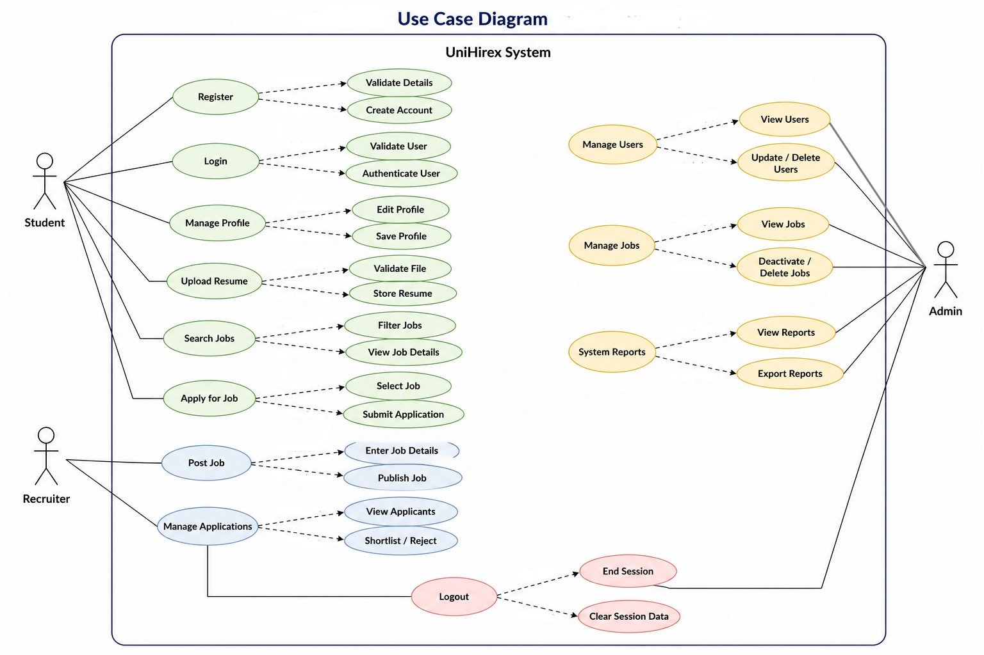

Activity Diagram
The activity diagram illustrates the overall workflow of the UniHirex system by representing the sequence of activities performed by different users, including students, recruiters, and administrators. It provides a clear visualization of how processes are executed within the system, starting from user access to the platform and continuing through various operations such as registration, login, profile management, job searching, and job application.
The diagram also includes recruiter activities such as posting job opportunities and managing applications, as well as administrative tasks like user management and system monitoring. Decision points, such as user authentication and role selection, are incorporated to show how the system responds under different conditions. By presenting the flow of control and interactions between different system components, the activity diagram helps in understanding the logical sequence of operations and ensures that the system processes are well-structured and efficient.
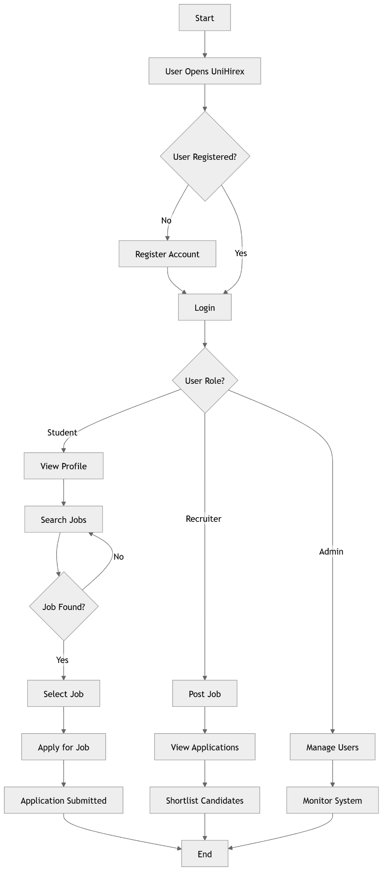

Class Diagram

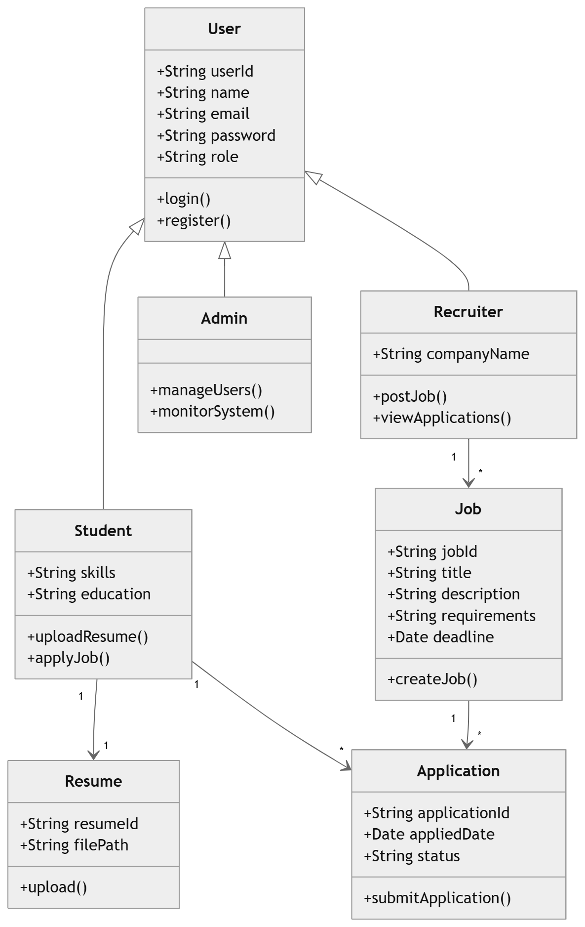

UML Diagram
The UML class diagram of the UniHirex system represents the structural design of the application by illustrating the main classes, their attributes, methods, and relationships. It shows how different entities such as users (students, recruiters, and admins), jobs, applications, and resumes interact with each other within the system. The diagram highlights inheritance relationships, associations, and multiplicities, providing a clear understanding of the system’s architecture and data flow. This helps in visualizing how the system components are organized and how they collaborate to support the recruitment process.

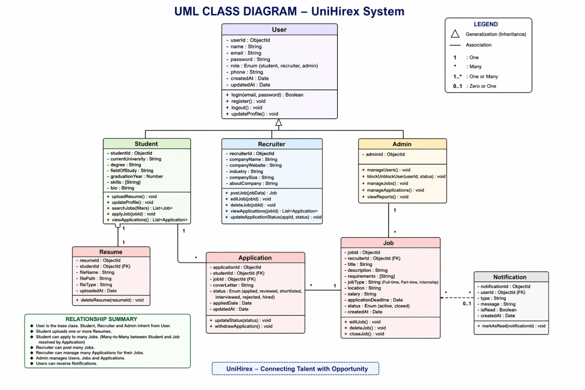

Sequence Diagram
The sequence diagram illustrates the interaction between different components of the UniHirex system during the job application process. It shows how a student communicates with the frontend interface, which then interacts with the backend server and database to retrieve job listings and submit applications. The diagram also represents how recruiters access and review submitted applications. This sequential flow helps in understanding the communication between system components and ensures that the process is executed in a logical and structured manner.

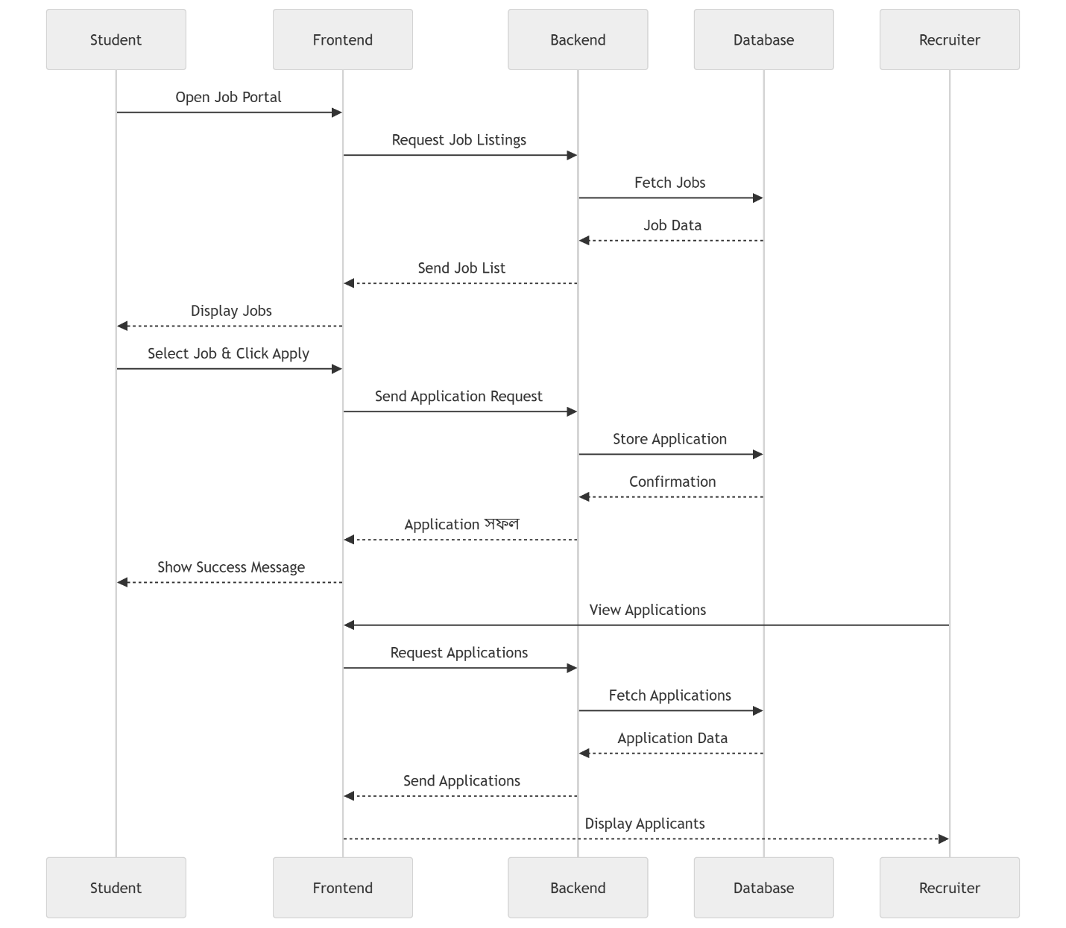

System Architecture Diagram
The system architecture diagram of UniHirex illustrates the overall structure and interaction of different components within the system. It follows a three-tier architecture consisting of the client layer, server layer, and database layer. Users, including students, recruiters, and administrators, interact with the system through the frontend developed using React.js. The frontend communicates with the backend server via secure HTTPS-based REST APIs. The backend, built using Node.js and Express.js, handles core functionalities such as authentication, user management, job posting, and application processing. Data is stored and managed in a MongoDB database. Additionally, external services such as file storage and email notifications are integrated to enhance system functionality. This architecture ensures a scalable, secure, and efficient platform for managing the recruitment process.

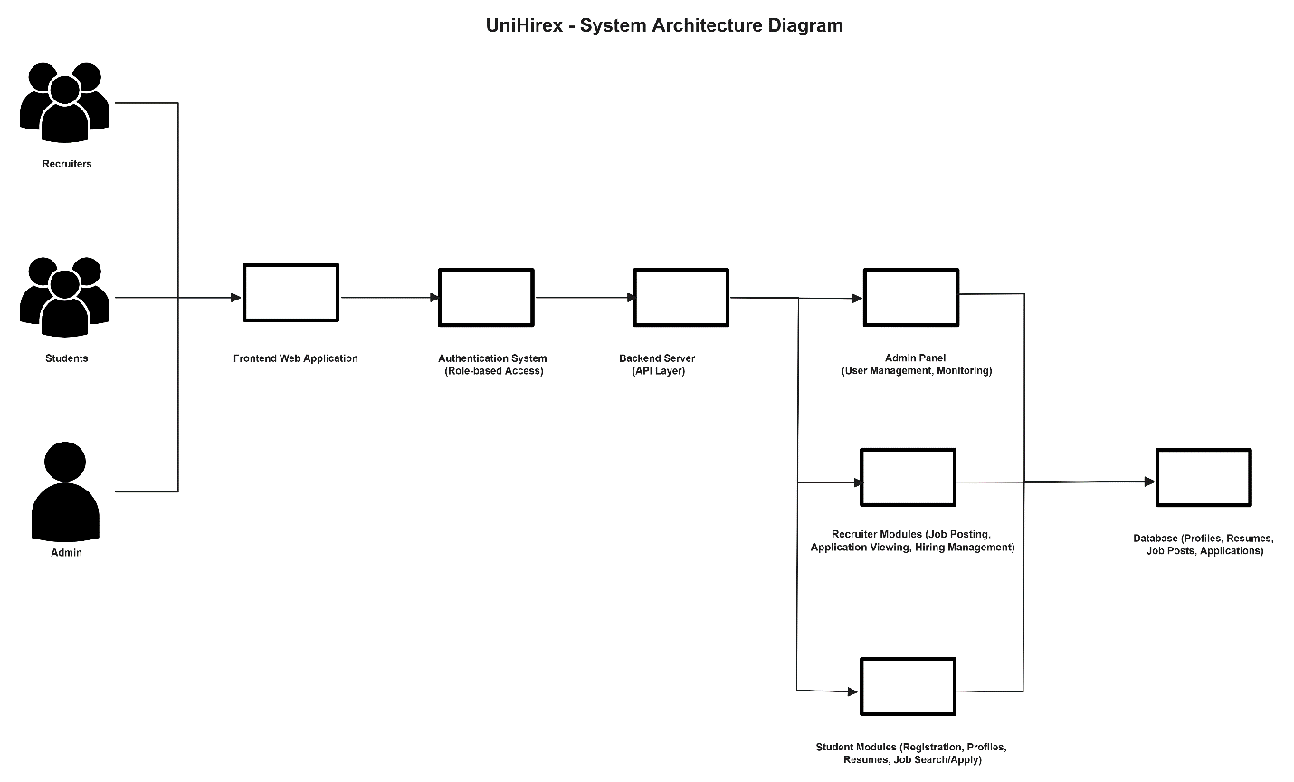

Use Case Descriptions
This section provides detailed descriptions of the individual use cases of the UniHirex system. Each use case represents a specific interaction between the system and its users, including students, recruiters, and administrators. The use cases are derived from the functional requirements and describe the sequence of actions, inputs, and outputs involved in performing various system operations.
Each use case includes important elements such as the use case ID, name, description, actors, preconditions, postconditions, basic flow, alternative flow, and exceptions. These descriptions help in understanding how the system behaves under different scenarios and ensure that all functional aspects of the system are clearly defined.

Use Case 1
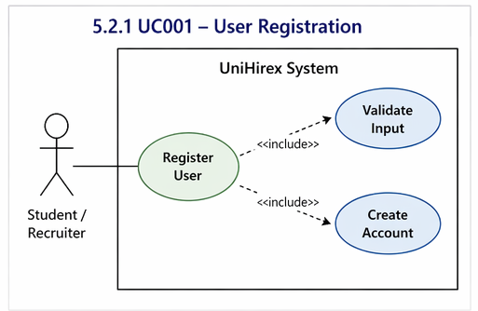
ID: UC001
Name: User Registration
Description
This use case describes the process through which a new user registers into system.
Requirement(s): FR001
Actor(s): Student, Recruiter
Precondition:
- The user must not already be registered in the system.
- The user must have a valid email address.
Postcondition:
- A new user account is successfully created.
- The user can log in to the system using their credentials.

Basic Flow
- The user opens the registration page.
- The system displays the registration form.
- The user enters required details.
3.1 Following fields are required:
- Full Name
- Email
- Password
- Phone Number
- Role (Student / Recruiter)
3.2 System validates the inputs:
- Email must be in valid format
- Password must be at least 8 characters
- Email must be unique
- The user submits the registration form.
- The system verifies all inputs.
- On successful validation, the system creates a new user account.
- The system displays a success message.

Alternative Flow
- If the user already has an account:
  - The user selects login instead of registration.

Exceptions
- Invalid input data (e.g., incorrect email format, weak password)
- Email already exists in the system
- System fails to save user data

Use Case 2
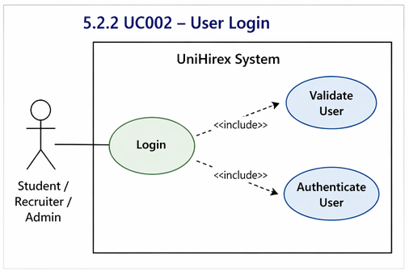
ID: UC002
Name: User Login
Description:
This use case describes the process through which registered users log in to the UniHirex system.
Requirement(s):
FR002
Actor(s):
Student, Recruiter, Admin
Precondition:
- The user must be registered in the system.
Postcondition:
- The user is successfully authenticated and redirected to their dashboard.

Basic Flow
- User opens login page.
- System displays login form.
- User enters email and password.
- System validates inputs.
- System authenticates credentials.
- On success, user is redirected to dashboard.

Alternative Flow
- User chooses “Forgot Password” option.

Exceptions
- Invalid email or password
- User not registered
- System error

Use Case 3
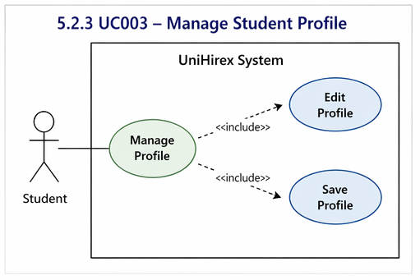
ID: UC003
Name: Manage Student Profile
Description
This use case allows students to create and update their profile information.
Requirement(s):
FR003
Actor(s):
Student
Precondition:
- Student must be logged in
Postcondition:
- Profile is created or updated successfully

Basic Flow
- Student logs into system.
- Navigates to profile section.
- Enters or updates details (education, skills, etc.).
- Submits changes.
- System saves updated profile.

Alternative Flow
- Student edits existing information

Exceptions
- Missing required fields
- System fails to update data

Use Case 4
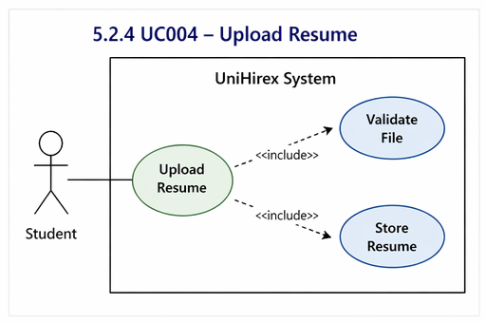
ID: UC004
Name: Upload Resume
Description
This use case allows students to upload their resume.
Requirement(s):
FR004
Actor(s):
Student
Precondition:
- Student must be logged in
Postcondition:
- Resume is uploaded successfully

Basic Flow
- Student opens profile section.
- Selects upload resume option.
- Chooses file from device.
- System validates file format.
- System uploads and saves file.

Alternative Flow
- Student replaces existing resume

Exceptions
- Invalid file format
- File upload failure

Use Case 5
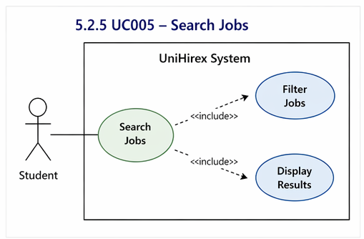
ID: UC005
Name: Search Jobs
Description
This use case allows students to search for jobs and internships.
Requirement(s):
FR005
Actor(s):
Student
Precondition:
- Student must be logged in
Postcondition:
- Relevant job listings are displayed

Basic Flow
- Student opens job search page.
- Enters keywords or filters.
- System processes search request.
- System displays matching jobs.

Alternative Flow
- Student browses jobs without filters

Exceptions
- No jobs found
- System fails to fetch data

Use Case 6
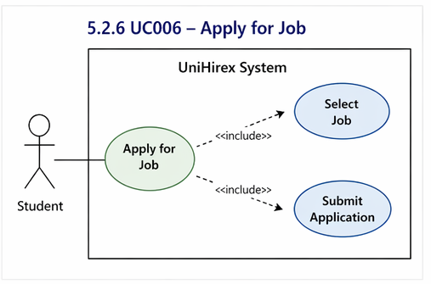
ID: UC006
Name: Apply for Job
Description
This use case allows students to apply for job opportunities.
Requirement(s):
FR006
Actor(s):
Student
Precondition:
- Student must be logged in
- Resume must be uploaded
Postcondition:
- Application is submitted successfully

Basic Flow
- Student selects a job.
- Clicks “Apply” button.
- System retrieves student profile and resume.
- Student confirms application.
- System submits application.

Alternative Flow
- Student cancels application

Exceptions
- Resume not uploaded
- Application submission fails

Use Case 7
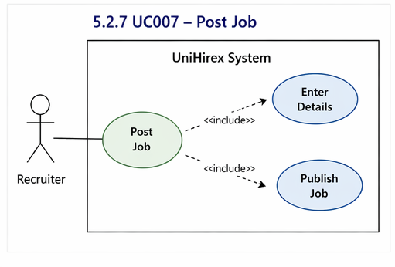
ID: UC007
Name: Post Job
Description
This use case allows recruiters to post job opportunities.
Requirement(s):
FR007
Actor(s):
Recruiter
Precondition:
- Recruiter must be logged in
Postcondition:
- Job is successfully posted

Basic Flow
- Recruiter logs in.
- Navigates to job posting section.
- Enters job details.
- Submits job post.
- System saves and publishes job.

Alternative Flow
- Recruiter edits job before posting

Exceptions
- Missing required fields
- System error

Use Case 8
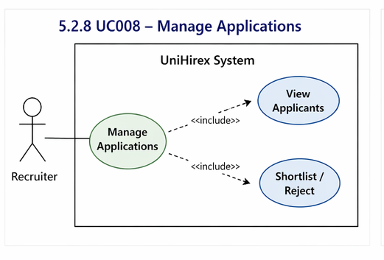
ID: UC008
Name: Manage Applications
Description
This use case allows recruiters to view and manage job applications.
Requirement(s):
FR008
Actor(s):
Recruiter
Precondition:
- Recruiter must be logged in
Postcondition:
- Applications are reviewed and updated

Basic Flow
- Recruiter opens applications list.
- System displays applicants.
- Recruiter reviews profiles.
- Recruiter shortlists or rejects candidates.

Alternative Flow
- Recruiter filters applications

Exceptions
- No applications available
- System fails to load data

Use Case 9
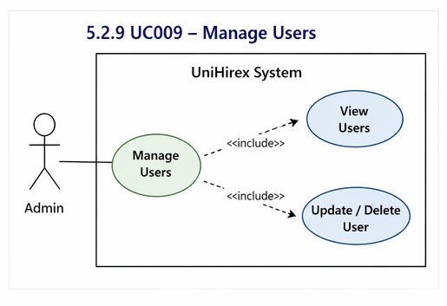
ID: UC009
Name: Manage Users
Description
This use case allows admin to manage system users.
Requirement(s):
FR009
Actor(s):
Admin
Precondition:
- Admin must be logged in
Postcondition:
- Users are managed successfully

Basic Flow
- Admin logs into system.
- Opens user management panel.
- Views user list.
- Updates or removes users.

Alternative Flow
- Admin searches specific user

Exceptions
- System fails to update data
- Unauthorized access

References
- [1] IEEE, IEEE Recommended Practice for Software Requirements Specifications, IEEE Std 830-1998, 1998.
- [2] R. S. Pressman and B. R. Maxim, Software Engineering: A Practitioner’s Approach, 8th ed. New York, NY, USA: McGraw-Hill, 2015.
- [3] I. Sommerville, Software Engineering, 10th ed. Boston, MA, USA: Pearson, 2016.
- [4] MongoDB Inc., “MongoDB Documentation,” [Online]. Available: https://www.mongodb.com/docs
- [5] Express.js, “Express Web Framework (Node.js),” [Online]. Available: https://expressjs.com
- [6] Meta Platforms, Inc., “React – A JavaScript Library for Building User Interfaces,” [Online]. Available: https://reactjs.org
- [7] OpenJS Foundation, “Node.js Documentation,” [Online]. Available: https://nodejs.org
- [8] “LinkedIn,” [Online]. Available: https://www.linkedin.com
- [9] “Indeed,” [Online]. Available: https://www.indeed.com
- [10] “Glassdoor,” [Online]. Available: https://www.glassdoor.com

